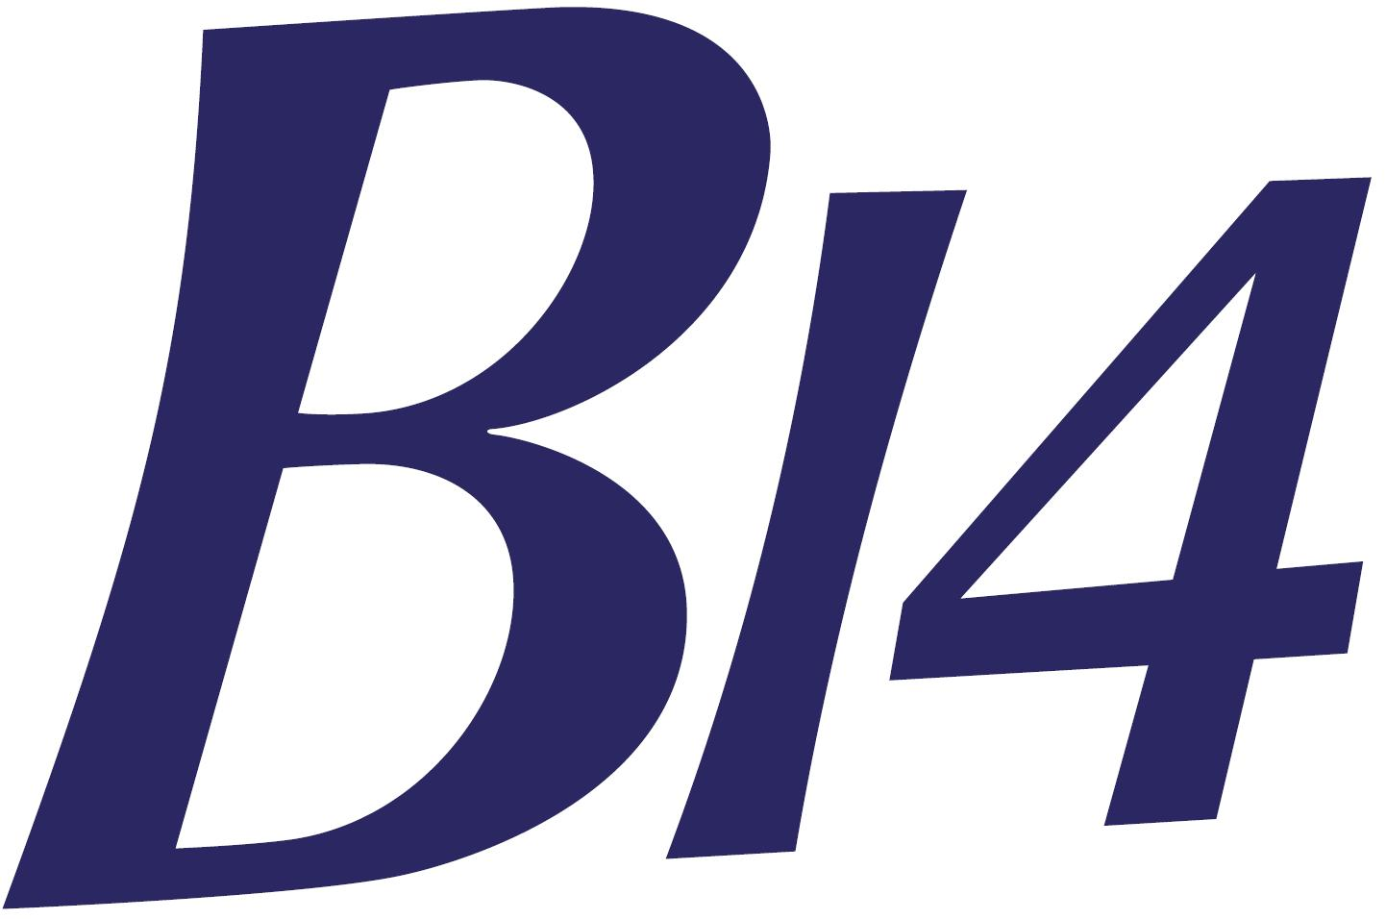 | B14 National and Open Championships  2nd – 5th August 2018  Paignton Sailing Club (PSC) | 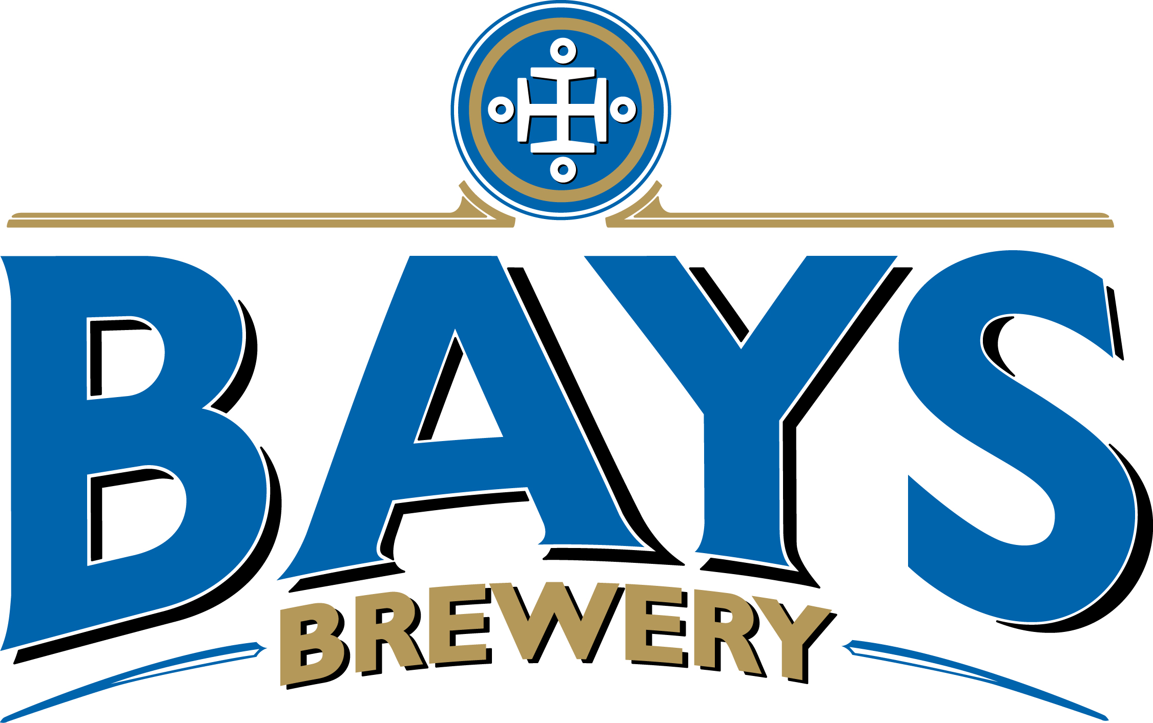

ENTRY FORM – Please enter details in the boxes

 |  | Entry Fee: | On or before 10th June 2018 - £135 |  |  |  |  | £
 |  |  | On or before 15th July 2018 - £150 |  |  |  |  | £
 |  |  | After 15th July + £10 |  |  |  |  | £

For entries received after 10th June or 15th July which do not include the additional amount will be required to pay the sum at registration
Assoc’n membership no. |  |  |  |  | Sail No.

Boat Name/Sponsor:
Helm |  |  |  | Mobile no.
Address |  |  |  | Age if under 18
 |  |  |  | Emergency contact name
Home Club |  |  |  | Emergency contact no.
Crew |  |  |  | Mobile no.
Address |  |  |  | Age if under 18
 |  |  |  | Emergency contact name
Home Club |  |  |  | Emergency contact no.

And now a couple of important questions!

Is there anyone in your party with special dietary requirements? Please specify

When are you hoping to arrive at Paignton SC?

You are welcome to join in with the club racing on Weds evening

Your entry fee includes:-

A glass of reviving beer immediately after racing each day. (Pasta is for wimps!)

Commodores Reception Buffet on Thurs

Leaky Games on Fri

Mexican meal and themed Sat evening – Biggest Sombrero and moustache prizes

And 4 whole days of social activity and fun like you’ve never known before!

Oh and there’s boat racing too! - 14 top class races run by top class PRO Ian Bullock

Extra tickets for the Mexican meal can be purchased at £7.50 each Please include amount with entry fee. |  |  |  |  |  | Number required |  |  | Total amount
 |  |  |  |  |  |  |  |  | £
Event Polo Shirts

We have arranged event polo shirts at £16 each. They are available in a variety of colours and sizes both ladies and mens. Please order below by 15th July. Please see separate sheet for colours and sizes, ladies or gents.
Ladies or Mens | Colour |  | Size |  | Number
 |  |  |  |  |  | £
 |  |  |  |  |  | £
 |  |  |  |  |  | £
 |  |  |  |  |  | £

By submitting this entry form, participants accept that: -
1. Competitors are entirely responsible for their own safety, whether afloat or ashore, and nothing whether in the Notice of Race or Sailing Instructions or anywhere else reduces this responsibility.
2. It is for the competitors to decide whether their boat is fit to sail in the conditions in which it will find itself. By launching or going to sea, the competitors confirm that the boat is fit for those conditions and they are competent to sail and compete in them.
3. Nothing done by the organisers can reduce the responsibility of the owners and / or competitors, nor will it make the organisers responsible for any loss, damage, death or personal injury, however it may have occurred, as a result of the boat taking part in the racing. The organisers encompass everyone helping to run the race and the event, and include Beer Sailing Club, the organising authority, the race committee, the race officer, patrol boats and beach masters.
4. The provision of patrol boats does not relieve the boat of her responsibilities.
5. The boat is required to hold adequate insurance including insurance against third party claims in the sum of at least £2,000,000 (or the equivalent in any other currency).
6. Rights to use Names & Likenesses: Competitors automatically grant to the organising authority without payment the right in perpetuity to make, use and show any motion pictures, still pictures and live, taped or filmed television of or relating to the event.

7. To take part wholeheartedly in any activity, social gathering and dressing up games (Mexican) the B14 committee see fit!

Parent/Guardian Declaration (for competitors under 18 during the event)
Under law, the competitor is my dependent and I accept the Disclaimer of Liability & Insurance paragraphs above which exclude my dependent’s right to claim compensation in certain circumstances. I confirm that my dependent is competent to take part and that I am responsible for my dependent throughout the event.
Parent/Guardian name |  |  |  | Contact Tel no. in case of emergency

By submitting this entry form we (named helm and crew above) agree to be bound by the Racing Rules of Sailing, the Sailing Instructions and the Rules of Paignton Sailing Club.

Entry + Extra meals + Polo Shirts Total amount payable |  |  |  |  |  | £
GDPR Statement
1. Your data will be saved and used for the purposes of organising this event.
2. In order to deliver the best and fairest racing possible, video and still photography may be used as part of the Management processes of this event.

Please indicate Yes or No
Would you like to be contacted regarding additional events or matters related to the B14 Class?
In order to attract sponsors which make events like this possible, please may we publish images from the event in which you may be recognisable?

Please email your completed entry form to:

Tony Blackmore – tony@sailsport.plus.com - 07977 512673

And transfer your entry fee via bacs to:

B14 Class Assoc at sort code 20 05 06 acc. 8072 8020 quoting surname and sail no.

Both entry form and FEE must arrive no later than midnight on the dates above.

